Te Toki Waka Ama Waitangi Regatta
10th February 2024
Lake Rotoroa, Hamilton
Te Toki Waka Ama
Pānui 1

EVENT SUMMARY
Te Toki initially created this event to celebrate the end of the Sprint season with our club and all our paddlers who may have been unable to participate at Sprint Nationals. It was to give our Taitamariki and Intermediate paddlers one last race before they set off on their Winter Sports. Each year we would invite a couple of clubs to join us and over the last few years the event has grown. It is also an opportunity for us to celebrate Waitangi Day in Hamilton with our Waka whānau and give other people the opportunity to witness and participate in our event. Due to covid and other health & safety issues regarding the Hamilton lake we have not been able to hold this event for the last couple of years and we are excited for 2024.

EVENT SCHEDULE

7:00am | Registration
7:30am | Karakia
7:45am | Managers meeting
8.00am | Race & safety briefings
8.30am | Racing starts
4.00pm | Racing finishes
4.30pm | Prizegiving
5.00pm | Closing Karakia

RACE SCHEDULE

To be advised at a later date

RACE DAY INFORMATION
Car Parking: Parking is available in the park, follow the drive into the lake down Innes Common and signs will direct you to the parking on the field. Turn into the field parking off the car park where all the stalls are situated.
Food: We encourage you to bring your own healthy kai, however a small range of food vendors will be available onsite to purchase kai.
Toilets: Toilets are located to the left of the Yacht Club.
First Aid: First Aid will be available at the Yacht Club.
Rubbish/Recycling: We encourage you to please take what you bring. However, there will be rubbish bins for both rubbish and recycling situated around the venue.
Alcohol/Smokefree: Alcohol, smoking, vaping and any other substance use is not permitted at this event, including all premises of the event. If you wish to vape or smoke please go to the entrance to the event.

WAKA DROP OFF
Waka Drop off for w1:
- Waka drop off will be available from 6.00am on the event day
- Waka drop off will be on the right hand side of the Yacht club and will be clearly signed.

RACE RULES
All entrants must be familiar with the Waka Ama New Zealand race and safety rules.
Refer to the following link for more information: Waka Ama NZ Race Rules

AGE DIVISIONS & RACE EVENTS

WAKA | DISTANCE | DIVISIONS | GENDER
W1 | 500m | Intermediate, J16, J19, Open, Master, Senior Master, Golden Master | Men & Women
W6 | 250m | Taitamariki | Boys, Girls, Mixed
W6 | 500m, 1000m | J16, J19, Open, Master, Senior Master, Golden Master | Men & Women

FEES

Fees: Fees for this event are per person by age division
PER PERSON BY AGE DIVISION (charged one fee according to age on race day)
Age Division | Cost
Taitamariki | $10.00
Intermediate | $10.00
J16 | $10.00
J19 | $10.00
Open | $20.00
Master | $20.00
Senior Master | $20.00
Golden Master | $20.00

ONLINE ENTRIES & PAYMENT
- Online entries are to be completed using the Waka Ama NZ online entry system.
Te Toki Waka Ama Waitangi Regatta
- All entries to be completed through your club admin – contact your club admin to process your entry
- No entries on the day, no exceptions
- Entries close on 6th February 11:59pm
- Rosters close on 7th February 11:59pm, rosters must be completed by close date, no exceptions
- Once entered, payment can be made online to:
  - Te Toki Voyaging Trust
  - 12-3122-0176411-52
  - Use your club, team name and division as your reference

SAFETY REQUIREMENTS
- All waka will be provided and have a Safety Check completed by Te Toki Waka Ama.
- All taitamariki and intermediate age divisions must wear life jackets. Races will not be held back for those without, so please ensure you have enough for all your teams.

INDIVIDUAL & TEAM WAIVERS
- Individual and Team waivers must be completed by all paddlers/teams
- All paddlers U18 must have their waiver signed by their parent/guardian
- Waivers can be sent to tetokiwakaama@gmail.com or handed in at the managers meeting on the day
- Individual & Team waivers can be found here: Waivers

CONTACT INFORMATION

- All enquiries please email: wakaama@tetoki.org
- All urgent matters please call: Turanga Barclay-Kerr 021 02744277
- Facebook: Te Toki Waka Ama

VENUE MAPS

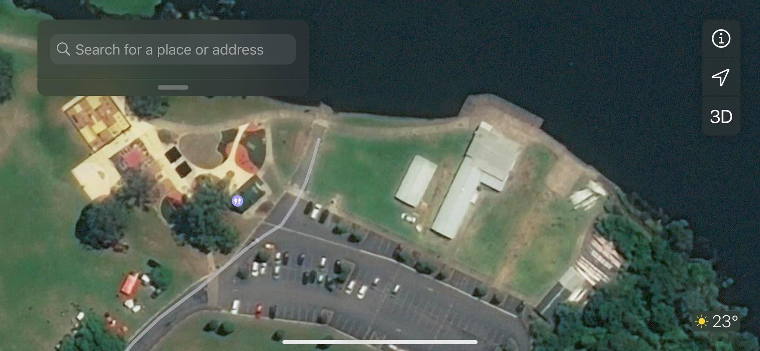
W1 s
Loading Bay W6

Loading Bay W1

Club tents

Club tents

Toilets

Stall Holders

Carparking

Club tents

RACE MAP

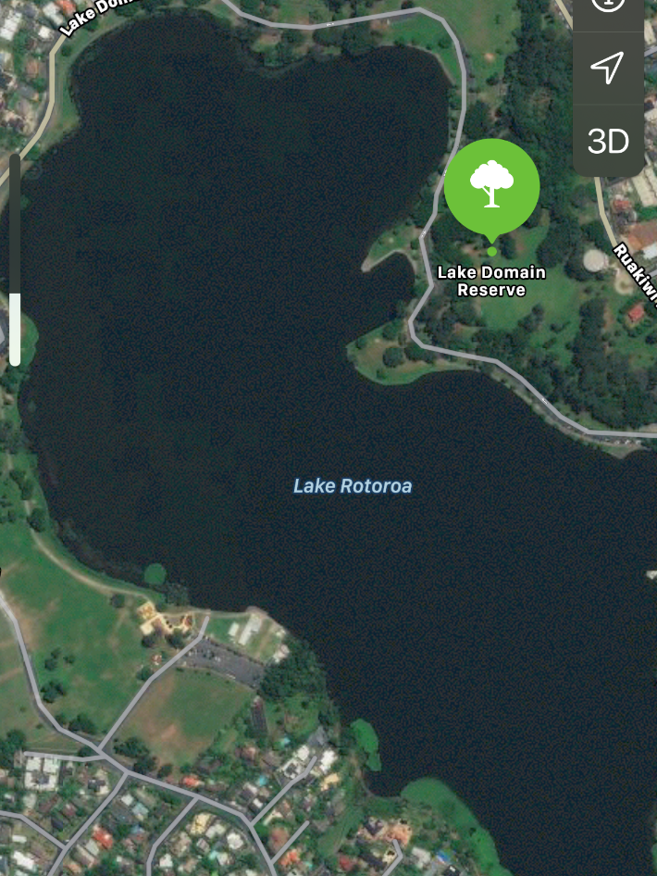
250m

1000m
500m

